IT Service Desk — Incident Resolution Report
Incident INC0012860

Ticket Summary
Ticket ID | INC0012860
Priority | Medium
Subject | Moved to a New Team and Cannot Access Their Files or Folders
Submitted By | Tom Wilson (twilson@servicedesk-simulator.com)
Request Type | Access Modification – Department Transfer
Employee Affected | Kavita Patel (username: kpatel)
Status | Resolved

Request Details
The requester (Kavita Patel's manager) reported that Kavita had moved from the Engineering team to IT Infrastructure and could no longer access her files or folders. Specific items requested:
- Grant Kavita access to the tools needed for her new role on IT Infrastructure.
- Revoke her previous Engineering access per security policy.
- Effective date: 2026-02-05. New role starts Wednesday — access needed by morning.
- Note: department and reporting-line changes are being handled separately by HR.
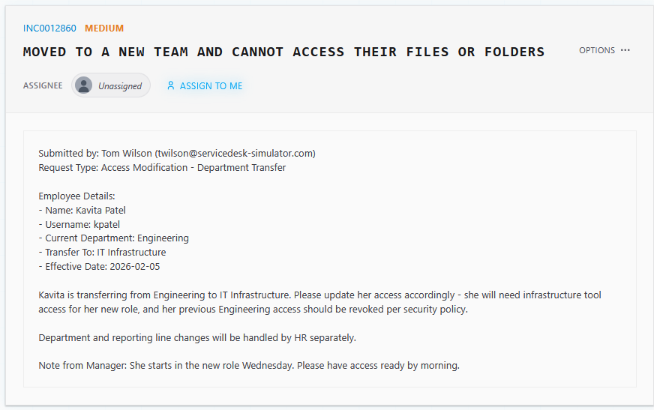
Figure 1 — Original ticket INC0012860

Actions Taken
- Located Kavita Patel's account (username: kpatel) in the Directory, Groups tab.
- Confirmed her existing group memberships: Domain Users, Engineering.
- Added her to the IT Infrastructure group to grant access to her new team's tools.
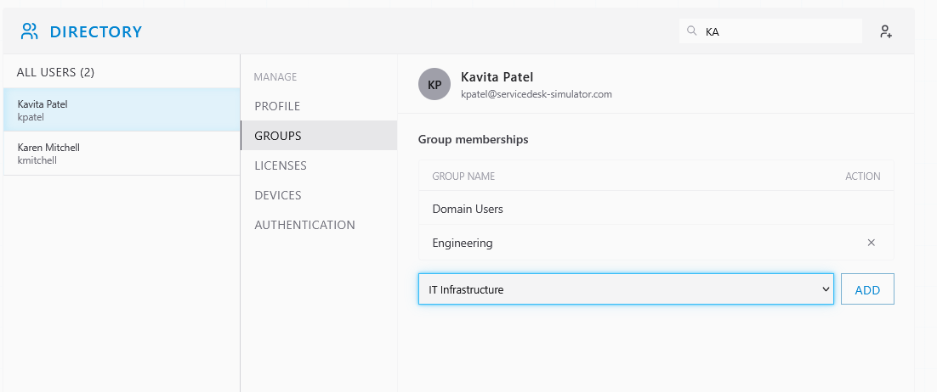
Figure 2 — Adding Kavita Patel to the IT Infrastructure group
- Removed her from the Engineering group to revoke her previous department access per security policy.
- Verified the final group membership showed Domain Users and IT Infrastructure only, with Engineering removed.
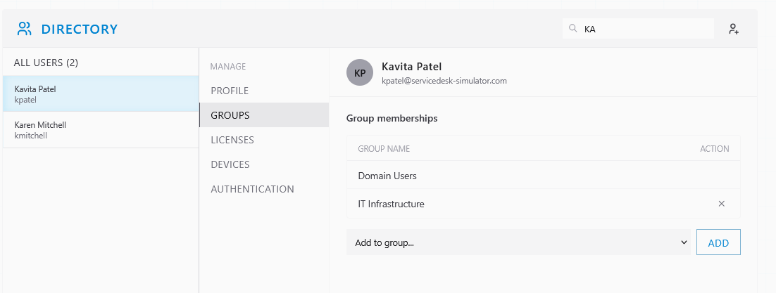
Figure 3 — Group membership after Engineering access was revoked

Resolution
Kavita Patel's group memberships were updated to reflect her transfer: IT Infrastructure access was granted and Engineering access was revoked, ahead of her new role start on Wednesday. No further action required.

Before / After Comparison
Field | Before | After
Group Memberships | Domain Users, Engineering | Domain Users, IT Infrastructure

Notes
Department and reporting-line changes are being handled separately by HR, per the requester's note, and were out of scope for this ticket.

Ticket Closure
Resolution notes (as entered on ticket close):
"I opened the user's account in the admin console, changed their team from the old group to the new one, applied the updated role, and confirmed their access rights and group membership were correct."
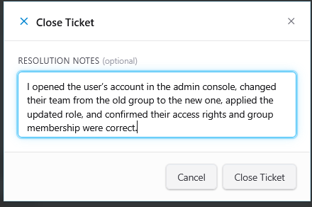
Figure 4 — Close Ticket dialog with resolution notes

